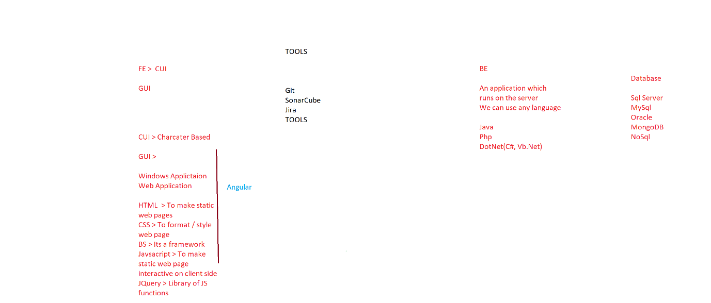

namespace Demo1 // namespace is a logical collection of classes

{

internal class Program // Min we need 1 class, that class

// shud have Main method

{

static void Main(string[] args) // Main is the entry

// and exit point of the application

{

Console.WriteLine("Hello1"); // Console is class

// It is in the System Namespace

Console.WriteLine("Hello2");

// WriteLine is a method of Console class

Console.WriteLine("Hello3");

}

}

}

//# include stdio.h Ctrl+KC > Comment

// Ctrl+KU > Uncomment